NAMA : ADE ILHAM PERMADI

TUGAS : CDM, PDM, ERD

1. CDM

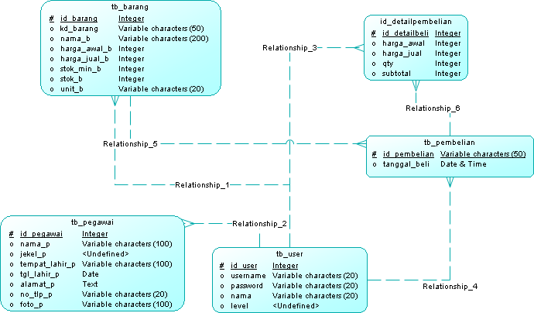

1. PDM

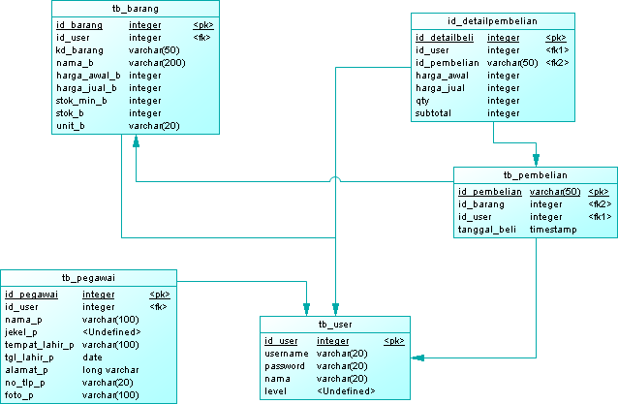

1. ERD

